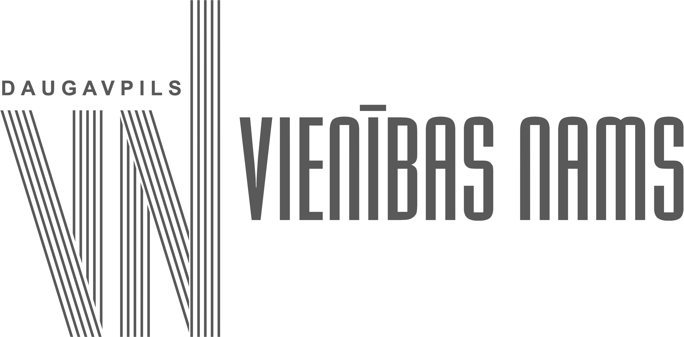

Pauls Krūmiņš’ International Orchestra Festival
REGULATIONS
17 - 19 October 2024, Daugavpils

The Pauls Krūmiņš’ International Orchestra Festival is organised by the Latvian and Latgalian Culture Centre of the Daugavpils State Municipality Institution "Vienības nams" (“Unity House”). The festival will take place in Daugavpils on 17-19 October 2024 and is open for all types of orchestras: brass bands, string orchestras, chamber orchestras, symphony orchestras, accordion orchestras, orchestras of folk musical instruments and others.
The aim of the festival is to preserve and develop the traditions of orchestral music-making in Daugavpils, to promote international cooperation with orchestras abroad and to honour the name of Pauls Krūmiņš, Latvian conductor and violinist, founder and leader of the first Latgale Symphony Orchestra, who worked in Daugavpils.
Festival Rules:
1. Each collective prepares a programme of its own choice of 20-35 minutes;
2. The number of musicians in the collective - from 14 to 50 members.

Application for the festival:
The application form (Annex 1) for participation in the Festival must be sent to e-mail kultura@daugavpils.lv by 16 September 2024. The application must be supplemented with:
- a brief description of the collective's creative biography (up to 2000 characters);
- a photograph of the collective (not less than 1000 px);
- a link to the collective's recordings, which are not more than 2 years old.

The organisers of the festival are reviewing applications and sending out invitations to the Pauls Krūmiņš’ International Orchestra Festival until 20 September 2024.
Transport, accommodation and meals during the festival are to be covered by the participants.

Personal data processing

Daugavpils City Council establishment „Vienības nams”, registration number 90000077556, legal address: 22a Rīgas Street, Daugavpils; as a Manager carefully treats the privacy of natural persons and observes the principles of personal data processing, namely:
• process personal data lawfully, fairly and in a manner that is transparent to the data subject;
• the processing has specific, explicit and legitimate purposes;
• the data processed are adequate, relevant and contain only the information necessary for the purposes;
• data is accurate and, where necessary, up-to-date;
• are stored in an appropriate manner and for no longer than is necessary for the purposes of the processing;
• ensure that the data subject's rights are respected.

Manager – Daugavpils City Council establishment „Vienības nams” registration number 90000077556, legal address: 22a Rīgas Street, Daugavpils;
Data subjects - senders of the application, participants of the festival.

In order to ensure the Festival, the Manager will process the following personal data:
1.Purpose – Identification of festival participants and verification of documents required for participation,
Type of processing - Compilation of lists of participants;
Legal basis – Article 6(1)(e) of Regulation (EU) 2016/679 of the European Parliament and of the Council of 27 April 2016 on the protection of natural persons with regard to the processing of personal data and on the free movement of such data and repealing Directive 95/46/EC ("GDPR") (processing is necessary for the performance of a task carried out in the public interest or in the exercise of official authority vested in the manager by law);
Personal data – name, surname, contact (phone/email), photo, name and surname of the leader, photo and video record, country represented, locality.
Categories of receivers – specialists of the Manager.
Data retention – one month after the festival, the collected, processed data after the deadline is permanently deleted;

2. Purpose – production and publication of festival information materials;
Processing - layout, printing, publication on the Daugavpils City Council website www.daugavpils.lv, www.vienibasnams.lv, https://www.facebook.com/daugavpilsvn;
Personal data - name and surname of the conductor and/or artistic director of the ensemble, soloist, photo, video, country represented, locality;
Legal basis - GDPR 6.1(e) (processing is necessary for the performance of a task carried out in the public interest or in the exercise of official authority vested by law in the manager);
Categories of recipients - public, website visitors, registered Facebook users;
Data retention - permanent.

3. Purpose – administering the payment of participation fees,
Method of processing - publication of information materials on the website of Daugavpils State Municipality www.daugavpils.lv, on the website of Daugavpils State Municipality institution "Vienības nams" www.vienibasnams.lv, www.vnfestivals.lv, on the Facebook account of the social network;
Personal data - name and surname of the conductor and/or artistic director of the ensemble, soloist, photograph, video, country represented, locality.
Legal basis - GDPR 6.1(e) (processing is necessary for the performance of a task carried out in the public interest or in the exercise of official authority vested by law in the controller);
Categories of recipients - public, website visitors, registered users of Facebook;
Data retention -5 years from the date of publication.

The Controller informs that the personal data:
- are not being profiled or used for automated decision-making;
- is not transferred to international organisations;
- data are not transferred to third countries or outside the EU/EEA.
The controller informs that Facebook may store backup copies of the data outside the EU/EEA. Facebook processes personal data for its own purposes in accordance with its personal data processing policy, which can be found here: https://lv-lv.facebook.com/privacy/policy/?entry_point=facebook_page_footer.

The controller informs that the data subject has the right to:
- to request from the Controller access to personal data concerning him or her, rectification or erasure of personal data, or restriction of processing concerning him or her, or the right to object to processing;
- to request additional information or lodge a complaint with the Controller - Daugavpils State City Municipality Institution "Vienības nams", Rīgas iela 22a, Daugavpils, contact person of the Controller: Poļina Bogdanova, e-mail: kultura@daugavpils.lv, tel. 654 26000, to the Data Protection Officer, e-mail: dati@daugavpils.lv, address: 1 Krišjāņa Valdemāra Street, Daugavpils; or to the supervisory authority - Data State Inspectorate, 17 Elijas Street, Riga, LV-1050.

For more information on how to join the festival:
Daugavpils State Municipality Institution "Vienības nams"
Phone: +371 65423601, +371 220613225
E-mail: kultura@daugavpils.lv
www.kultura.daugavpils.lv; www.vienibasnams.lv

Artistic Director of the Festival:
Jevgenijs Ustinskovs, phone: +(371)29538278

Annex 1

FESTIVAL APPLICATION FORM

Please fill in the form in computer, MS Word format and send it electronically to kultura@daugavpils.lv by 16 September.

Name of the orchestra, country represented, place of residence | Name of conductor/artistic director | Contact person’s phone number, e-mail address | Preferred performance day | Titles, authors and duration of the planned pieces | Internet link to the video recording

By submitting an application, the participant (representative) declares that
- has read the Festival Regulations,
- has been informed about the processing of personal data during the Festival and has informed the other participants whose data are submitted about the processing of their personal data,
- has been informed of his/her rights (as a data subject) in relation to the processing of personal data: the right to be informed about the processing of personal data, to access his/her personal data, to rectify the data, to restrict the processing of data, to object to the processing of data and the right to exercise his/her rights as a data subject to contact the Controller's contact person, the Controller's data protection officer or to lodge a complaint with the Data Inspectorate.

Representative (conductor/artistic director/contact person) of the group:

____________________________________ /name, surname/

