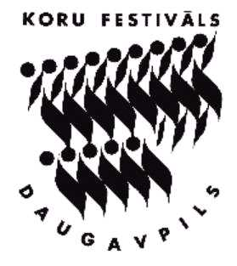

XI International Sacred Music Festival “Silver Bells”
8 to 11 January 2015, Daugavpils (Latvia)

SPECIAL PRIZES

The Prize of the Daugavpils Music College – for the performance of the composition written by Latvian composer – Mixed choir “Domino” / conductor Eduards Fiskovičs

The Prize of the Daugavpils University Faculty of Art – for the most interesting programme – University of Latvia mixed choir “Dziesmuvara” / conductor Aivis Greters

The Prize of the Daugavpils Centre of Latvian Culture – for the performance of the Latvian folk song – Women’s vocal ensemble “Akcents” from Skrīveri Culture Centre / head Laura Jēkabsone

The Prize of the Daugavpils Centre of Russian Culture – for the best sacred music performance – Chamber choir “Martakkord” / conductor Tatjana Dmitriyeva

The Prize of the Daugavpils Centre of Polish Culture – to the most expressive choir – Women’s vocal ensemble “Akcents” from Skrīveri Culture Centre / head Laura Jēkabsone

The Prize of the Daugavpils Centre of Belorussian Culture – for the best performance of a contemporary work – Chamber choir “FEST” / conductor Ella Storozhuka

The Prize of the Daugavpils Lithuanian society “Rasa” – for the best performance of the national composer – Ensemble "Kivi Junior“ from Lithuania Youth Centre / head Danguole Aukseliene

The Prize of the Daugavpils Association of music teachers – for the high teaching skills - conductor Pekka Nebelung / Children’s choir “KaMu-choir” and Children’s vocal ensemble “KaMu - Ensemble”

