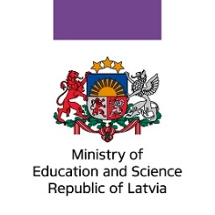
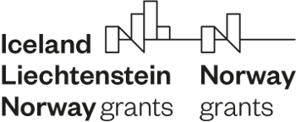

European Economic Area financial mechanism and Norway financial mechanism programme “Research and Education” (Programme)
Cooperation Committee (CC) meeting
20 -21 June 2022

Location: 20 June - Ventspils, 21 June – Liepaja, Latvia
Draft Agenda
Participants: members and observers of the Cooperation Committee, representatives of all four innovation centres projects
20 June – Ventspils, Latvia
 | Time | Topic | Presenters
 | Coffee break at 11.30
1. | 12.00 – 12.10 | Introduction.  Approval of the Agenda. | Lana Franceska Dreimane, Head of Research Programmes’ Unit, Ministry of Education and Science, PO, Head of CC
2. | 12.00 – 12.15 | Opening Speech | Royal Norwegian Embassy in Riga
3. | 12.15 – 12.25 | Scholarship Activity.  Results of 2nd open call.  Implementation of 1st Call projects. Next steps. | Herberts Bucenieks, Head of International Cooperation Programmes Unit, State Education Development Agency
4. | 12.25 – 12.35 | Update of the Bilateral Fund’ plan | Antra Jansone  Ministry of Education and Science, PO
5. | 12.35 – 12.55 | Cesis innovation centres project.  Project implementation: results, challenges, proposed solutions.  Questions, answers. | Pauls Irbins,  Head of Project Implementation team  Cesis Innovation centre
6. | 12.55 – 13.15 | Daugavpils innovation centres project.  Project implementation: results, challenges, proposed solutions.  Questions, answers. | Jolanta Uzulina,  project manager  Daugavpils Innovation centre
7. | 13.15 -13.35 | Liepaja innovation centres project.  Project implementation: results, challenges, proposed solutions.  Questions, answers. | Laura Grundmane, project manager  Liepaja Innovation centre
 | Lunch 13.35 -14.25
8. | 14.25 – 14.45 | Ventspils innovation centres project.  Project implementation: results, challenges, proposed solutions.  Questions, answers. | Kristine Bergmane-Korate, project manager  Ventspils Innovation centre
9. | 14.45 -15.00 | Other questions

15.00 -15.30 | Opening of exhibition #researchLatvia  Coffee | Rupniecibas iela 2, Ventspils | Ministry of Education and Science

15.30 – 17.00 | Visit of Ventspils innovation centre | Rupniecibas iela 2, Ventspils | Kristine Bergmane-Korate, project manager

17.00-19.00 from Ventspils to Liepaja
20.00 Dinner in Liepaja
Hotel in Liepaja
21 June – Liepaja, Latvia
10.00 -12.30 | Visit of Liepaja innovation centre | Nature House, Zirgu sala 2 and Autoru iela 4/6, Liepaja | Laura Grundmane, project manager  Liepaja Innovation centre

13.00 – 14.00 Lunch in Liepaja

